|  |  |
| --- | --- |
| C:\Users\Pranish\AppData\Local\Microsoft\Windows\INetCache\Content.MSO\C66BB4DA.tmpUSER INSTALLation manual  ITECH 3209 - Project 2 | Abstract  This is the user’s manual for Order Management System developed by Group 6 -Revenant Dawn. It is intended to introduce our cloud application from the user’s point-of-view on how to access our website and use its features.  GROUP 6  Lecturer: Mr. Ahmad Saeed  Tutor: Mr. Nellai Seetharaman  PRODUCT:  Order Management System |

Group Members

|  |  |  |  |
| --- | --- | --- | --- |
| Last Name | Given Names | Role | Student ID |
| Shrestha | Pranish | Scrum Master | 30345392 |
| Poudel | Madan | Team Member | 30338401 |
| Ghimire | Nabin | Team Member | 30349622 |
| Shrestha | Kanchan | Team Member | 30344274 |
| Joshi | Paras | Team Member | 30347755 |

Team Name:



Table of Contents

**1.** **Introduction** 3

**2.** **General Overview** 3

2.1 Document Overview 3

2.2 Document Version Control 3

2.3 Project References 3

2.4 Team Overview 4

2.5 Organization of manual 5

2.6 Definition and Acronyms 5

**3.** **Technical specifications or minimum platform requirements** 6

3.1 Obtaining the product 6

3.2 Technical specification/ Minimum Requirements 6

3.3 Installation guide for browsers for accessing our website 7

3.3.1 Mobile Phone/ Smartphones 7

3.3.2 Desktop/Laptop 7

**4** **System Summary** 8

4.1 System Configuration 8

4.2 Data management 8

4.3 User Access Level 8

**5** **Getting Started** 8

5.1 Register Account 8

5.2 Forgot password 9

5.3 Log In 9

**6** **Using the website** 10

6.1 View Dashboard 10

6.2 View/edit Profile 11

6.3 Check the Product Stock 12

6.4 Add an Order 12

6.5 Viewing the pending orders 12

6.6 Editing Order 13

6.7 Adding product 13

6.8 Feedback form 14

6.9 Notification Panel 14

6.10 View Items Categories 15

6.11 Product detail 15

6.12 Watch it later Section 16

6.13 Checkout 16

6.14 Add stock to inventory 17

**7** **Conclusion** 17

**8** **Appendix** 18

7.1 Site Map 18

7.2 Publishing the Document 18

# **Introduction**

This is our User Installation& Manual document for the Order Management System, and we have included the various installation scenarios according to our experience in deploying the website. We have included sample text to describe the type of materials which is generally provided in the documents. This documentation is all from the contents of sprint 1 to sprint 5.

This is an installation and manual user document which is produced using MS Word as well as snipping tool to capture screenshots.

The purpose of this documentation is to introduce the system or components to be installed or used. Identify the benefits that will come from this installation and to provide a manual that a user of the Order Management System can access and important functions each role have. It also shows how to use the website in many users access level.

# **General Overview**

## 2.1 Document Overview

For this project, we already did five documentation named as sprint 1 to sprint 5. For the documentation, we use the MS office, google docs, Adobe, and some software such as Draw.io, Visual Paradigm for the images.

The main purpose of the document is to provide the full access to our project overview. We are going to provide the information relating to our Web-Based cloud application. Using this documentation, the customer/client can easily browse and use our application and refer to this document if they face any problem.

## 2.2 Document Version Control

|  |  |  |  |
| --- | --- | --- | --- |
| Version | Date | Author | Rationales |
| 0.1 | 25 May 2020 | Pranish Shrestha | Initial Draft |
| 0.2 | 26 May 2020 | Nabin Ghimire | Website review and documentation |
| 0.5 | 29 May 2020 | Madan Poudel and Paras Joshi | Wider review of the documentation |
| 0.8 | 5 June 2020 | Pranish Shrestha and Kanchan Shrestha | Updated deliverables |
| 1.0 | 7 June | Pranish Shrestha | Final version |

## 2.3 Project References

**Overview of the project**

The main aim of the project is to build an **order management system**. It is a web-based cloud application. This application mostly helps in managing the stocks, orders, delivery times, and overall reporting of the project. This project focus on the business to business (B2B) model.

The cloud-based web application that we currently have is focuses on the lighting products such as lamps, tube light, led light etc.

The project is made possible with help of stack called MongoDB as a database, Node JS as backend, EJS as a templating engine, NPM as node package manager, Express as a Middleware to create REST API.

**Revenant Dawn group**



The project team that made it possible to complete this application is Revenant Dawn**.** We are focused on providing excellent product to our client and the stakeholders of the project. The development of the new techniques in our project will help everyone to get the rightful information relating with the cloud-based application.

The Revenant Dawn is an overarching group and we are responsible for reviewing and providing different views and opinions. Also, we take and give advice in relation with the different proposals and help to implement it.

**Scope**

The scope of team **Revenant Dawn** will be to provide the feedback and the comment related with the project. Any issue related with the cloud-based application will be handle by the team revenant dawn and we will try to fix an issue as soon as possible.

**Key Tasks**

The members of the Revenant Dawn group are working as an advisory group and key tasks include as follows:

* Review and provide feedback
* Take advice regarding risk and opportunities
* Provide full access to the helpful information
* Provide comment regarding roles and responsibilities
* Provide key documents and resources of this group.

## 2.4 Team Overview

There are altogether 5 people in the group whose roles and responsibilities are shown below.

|  |  |  |
| --- | --- | --- |
| Name | Details | Role |
| Pranish Shrestha | Project Manager | Programmer |
| Nabin Ghimire | Team Member | System Analyst |
| Paras Joshi | Team Member | Quality Assurance leader |
| Madan Poudel | Team Member | Interface Designer |
| Kanchan Shrestha | Team Member | Debugger |

## 2.5 Organization of manual

It is defined as the organizational charts that helps in building the structure of the organization and the relationships. We can see the important aspects of our project including major functions and the relationship. For this, there should be different aspects working together. Therefore, we are trying to show the different aspects in the list. They are as follows:

* Contents of Organization

The different organizational manual that helps the user to identify the product are listed below:

* **Product manual**

This manual helps users to find the product.

* **Installation manual**

This helps to set-up and install the product provided in the application.

* **User manual**

Focuses on different users such as admin, manager of the project, maintenance staff, and so on

* **Operations Manual**

It relates with the operation of the business, standards of the project, privacy of the project.

## 2.6 Definition and Acronyms

A list of acronyms and abbreviations used in our project are

|  |  |
| --- | --- |
| **Acronyms** | **Abbreviations** |
| PMBOK | Project Management of Body and Knowledge |
| OMS | Order Management System |
| DB | Database |
| API | Application Programming Interface |
| JSON | JavaScript Object Notation |
| APP | Application |
| CRM | Customer Relationship Management |
| EJS | Embedded JavaScript |
| CRUD | Create, Read, Update and Delete |
| NPM | Node Package Manager |
| REST | Representational State Transfer |

# **Technical specifications or minimum platform requirements**

This manual is for the user to guide throughout the entire process involving the use of the product. This is a handbook that guides you to have a walkthrough to the website.

3.1 Obtaining the product

The website can be accessed through the following link. Clicking on it will redirect it to registration page where user can either sign in or sign up.

<https://ordermanagementsystemv1.herokuapp.com/>

3.2 Technical specification/ Minimum Requirements  
The minimum requirements to run the website would be any device that supports browsing and internet capabilities.

**Laptop and MAC**

* Window 8 and above & IOS above 8.0
* Standard browser
* Chrome and safari

**Plug-ins**

For Interactive contents Following plug-ins might be required

* Adobe Flash Player
* Adobe Reader

**JavaScript**

* JavaScript setting on the browser should be On

**Memory**

The memory is based on the computer capability of running the browser. Since chrome consumes lot of memory, below requirements is needed to efficiently run the cloud application.

* 2 GB minimum, 4 GB recommended

**Internet Connection**

* Stable Internet connection

**Browser versions meeting below versions or later**

The most recommended browser is latest version of **Chrome** since there are dependency that relies on chrome browser dev tools.

* Chrome 83.
* Safari 13.1.
* Edge 83.
* Firefox 76.
* Internet Explorer 11.
* Opera 68.
  1. Installation guide for browsers for accessing our website

### 3.3.1 Mobile Phone/ Smartphones

**Android**

Chrome installation instruction and running website:

1. On your phone go to Google Play
2. Type chrome
3. Tap install
4. Tap accept to agree to terms and condition
5. To start browsing go to home and tap chrome app
6. Tap on search and paste the following link
7. https://ordermanagementsystemv1.herokuapp.com

**IOS**

Safari installation instruction and running website:

1. On your phone go to App store
2. Type safari
3. Tap install
4. Tap accept to agree to terms and condition
5. To start browsing go to home and tap safari app
6. Tap on search and paste the following link
7. https://ordermanagementsystemv1.herokuapp.com

### 3.3.2 Desktop/Laptop

**Window Computer**

Chrome installation instruction and running website:

1. On your pc go to Microsoft edge app
2. Type chrome installation
3. Download chrome browser from the link
4. Click on install
5. To start browsing go to chrome app
6. paste the following link on search box
7. https://ordermanagementsystemv1.herokuapp.com

**MacBook**

Macintosh OS X 10.11 or later

* Safari 10.0 or later
* Google Chrome: latest edition
* Firefox: latest edition

Safari installation instruction and running website:

1. Safari is pre-installed on mac
2. Open safari app
3. Go to search box
4. paste the following link on search box
5. https://ordermanagementsystemv1.herokuapp.com

# **System Summary**

## 4.1 System Configuration

Order Management system can be opened or accessed from any kind of web browser like google chrome, safari, Mozilla Firefox etc. The application will run on any device that supports internet connection and browsing capabilities. It can be used only on laptop or personal computer. It can be accessed from mobile, tablet etc.

## 4.2 Data management

The data is stored by the user and agent databased is used with the server **MongoDB**. All the data which includes form, image, text, files are saved into the database the encryption. Only an authorized user can access to their personal data and they can update their data as well.

## 4.3 User Access Level

There will be 4 access levels of users and they are service user, order management user, logistic manager and administrator access. Among them public users can access only few parts of website. Service user will have limited capabilities of the website while administrator will have all rights to access any features.

# **Getting Started**

## 5.1 Register Account

User can register onto the website with their Email, Username and Password.

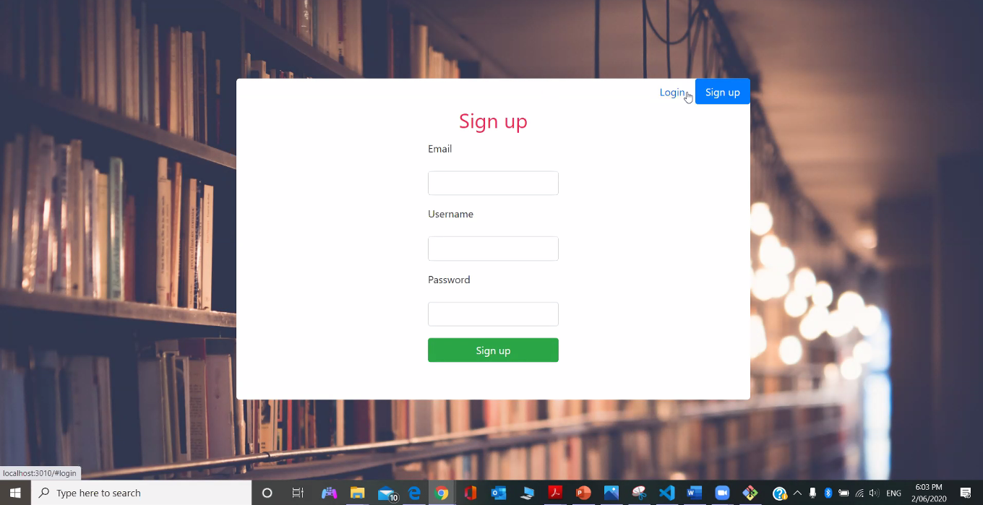

## 5.2 Forgot password

If the user forgets the password, they can reset their existing Username. There will be option to use email instead of username as well.

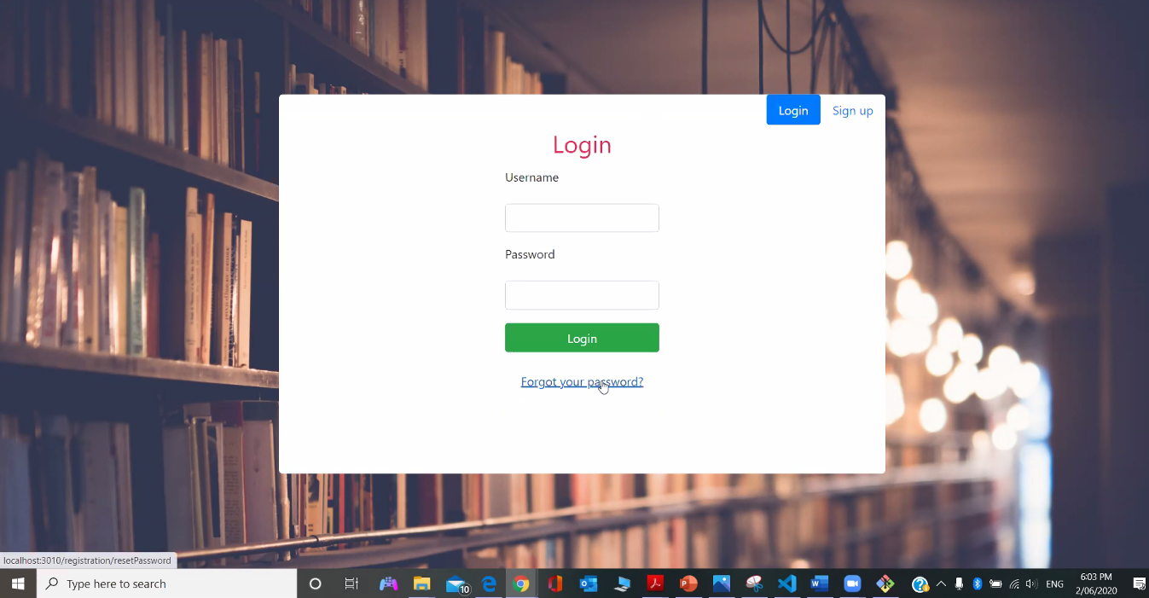

## 5.3 Log In

User can login with their Username and password.

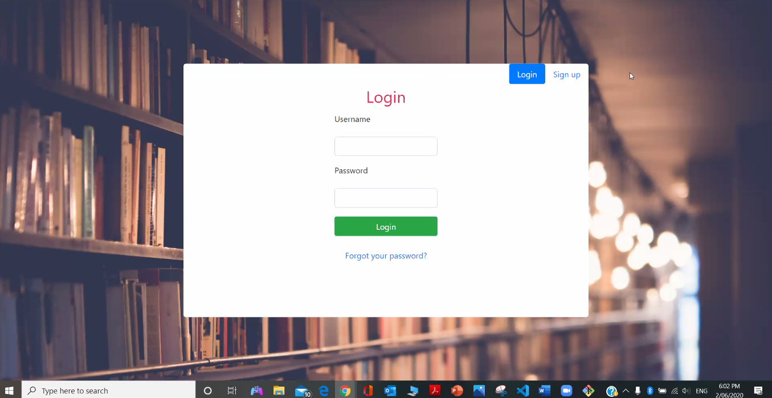

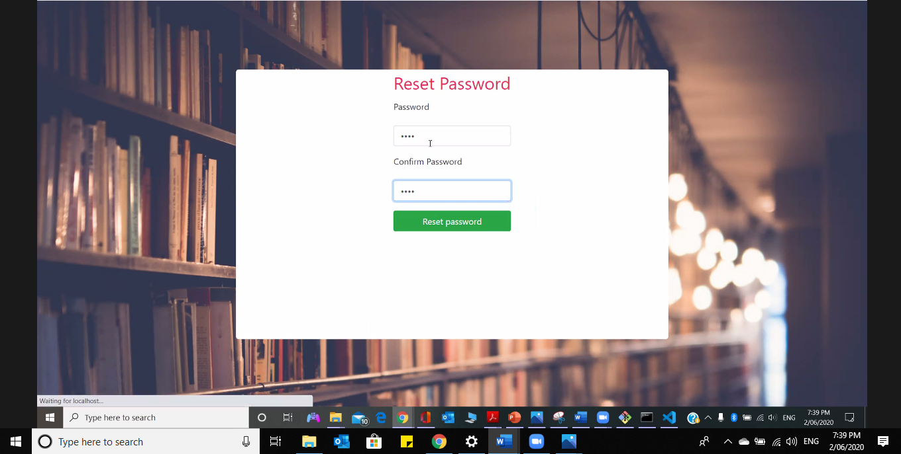

# **Using the website**

## 6.1 View Dashboard

After the logged in , it will displayed dashboard/ home page and it has the bar graph along with the some more button and link.

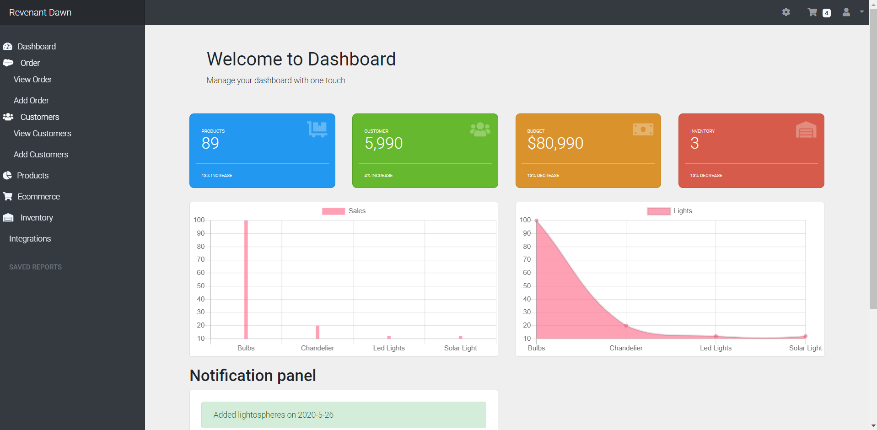

## 6.2 View/edit Profile

Profile of the user details regarding their Name, User type, Email and Phone Number. Users can view their profile and also can edit their profile. They just need to click on the profile icon which is at the top right corner of the website.

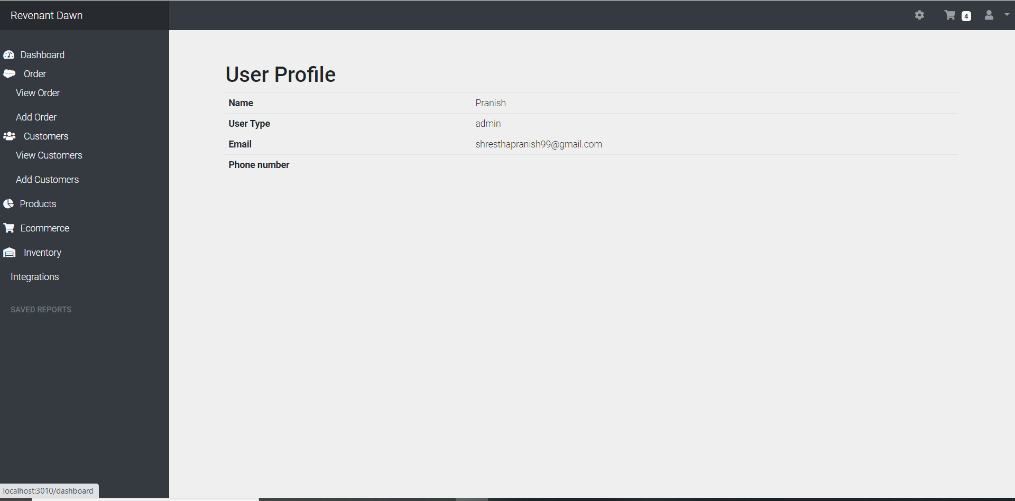

## 6.3 Check the Product Stock

It is the User’s database regarding the available stock. To find the database, users need to click on Inventory button which is on the left side of the website.

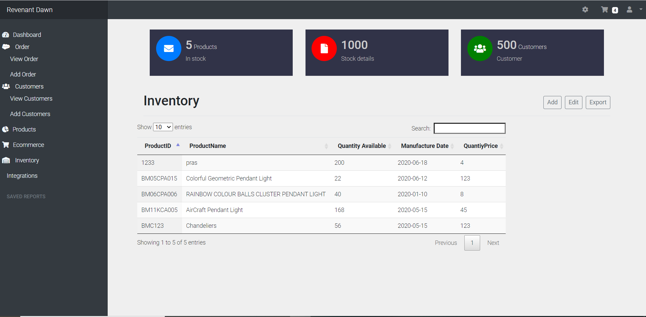

## 6.4 Add an Order

It means adding an Order by the user for what they wanted to order. User need to go to order page and again click on add order button and fill out the form to create an order.

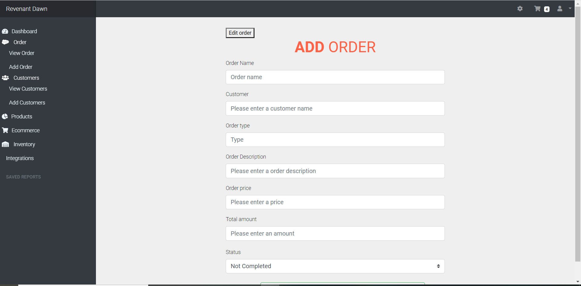

## 6.5 Viewing the pending orders

It means User’s viewing the items which they wanted to order. Users can click on shopping cart Icon and view order button to view the pending orders.

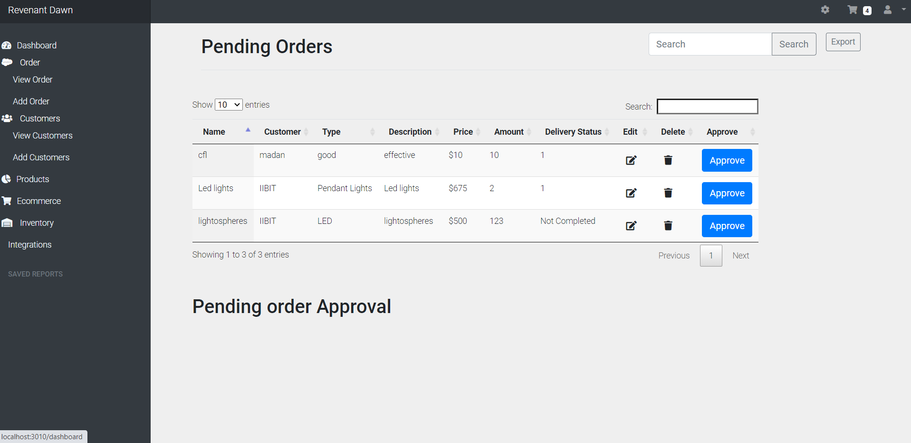

## 6.6 Editing Order

Users can edit the order as per their demand. They need to need to go to order page and again click on edit order button and fill out the form to edit an order.

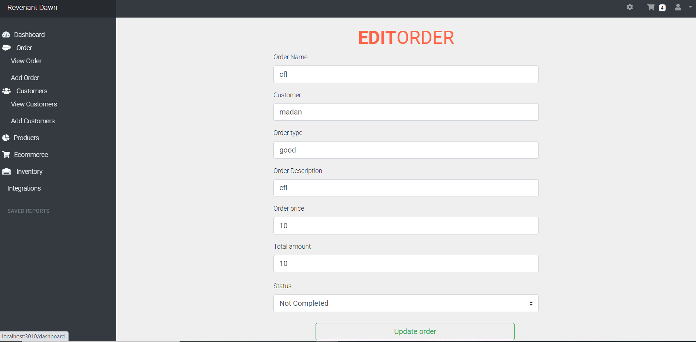

## 6.7 Adding product

It is in the secondary navigation under global primary navigation. Consists of Product Name, Product Description, Product Price, Product Category, Product Thumbnail. It can be done by

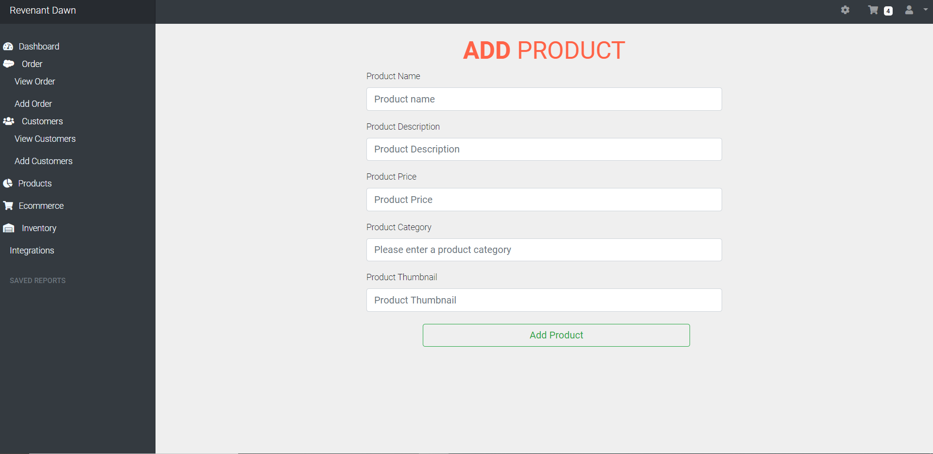

## 6.8 Feedback form

User can give a feedback regarding system and request for feature to be add by using this form.

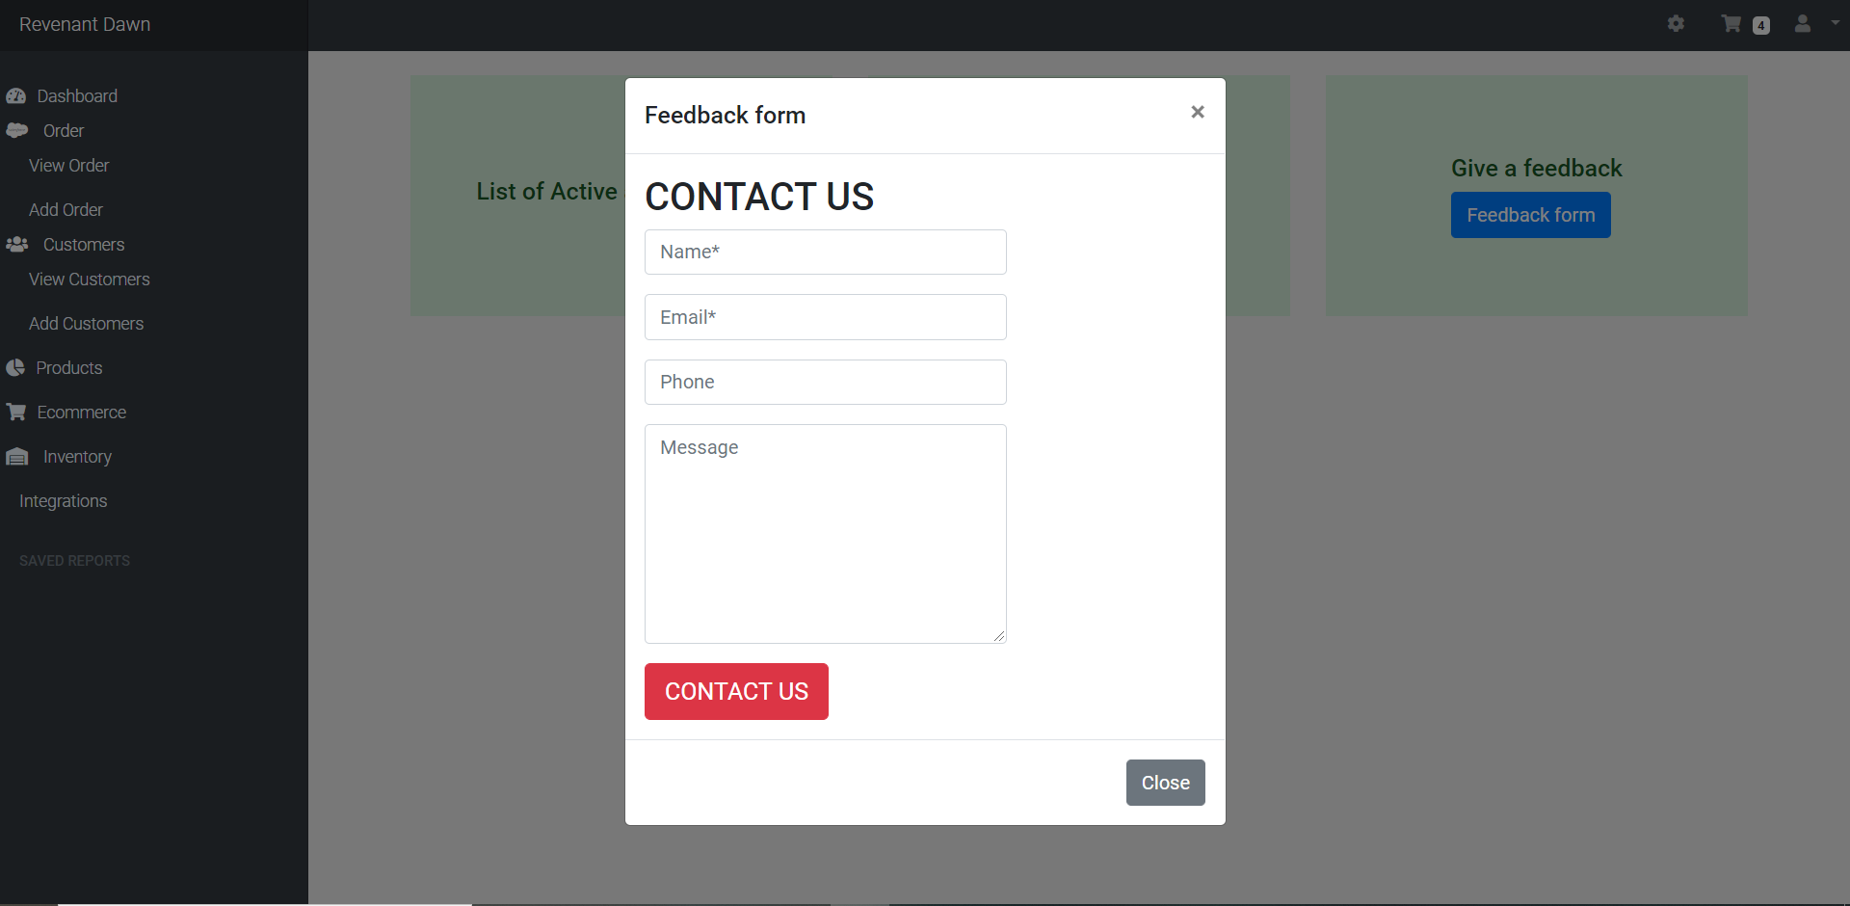

## 6.9 Notification Panel

Recent Information such as added order, updated customer are provided in the notification panel. It is located at the bottom of the home page.

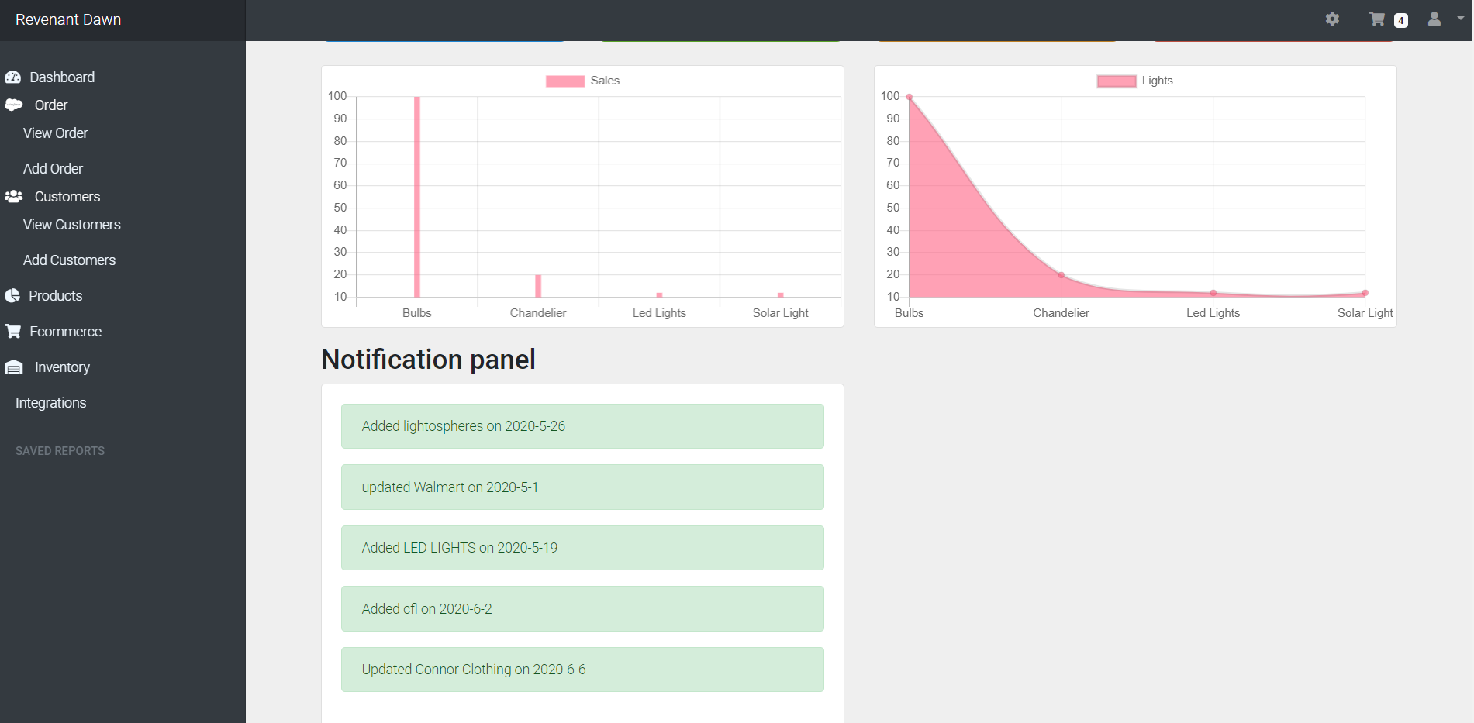

## 6.10 View Items Categories

Navigation sections for the items with their type, style and so on.

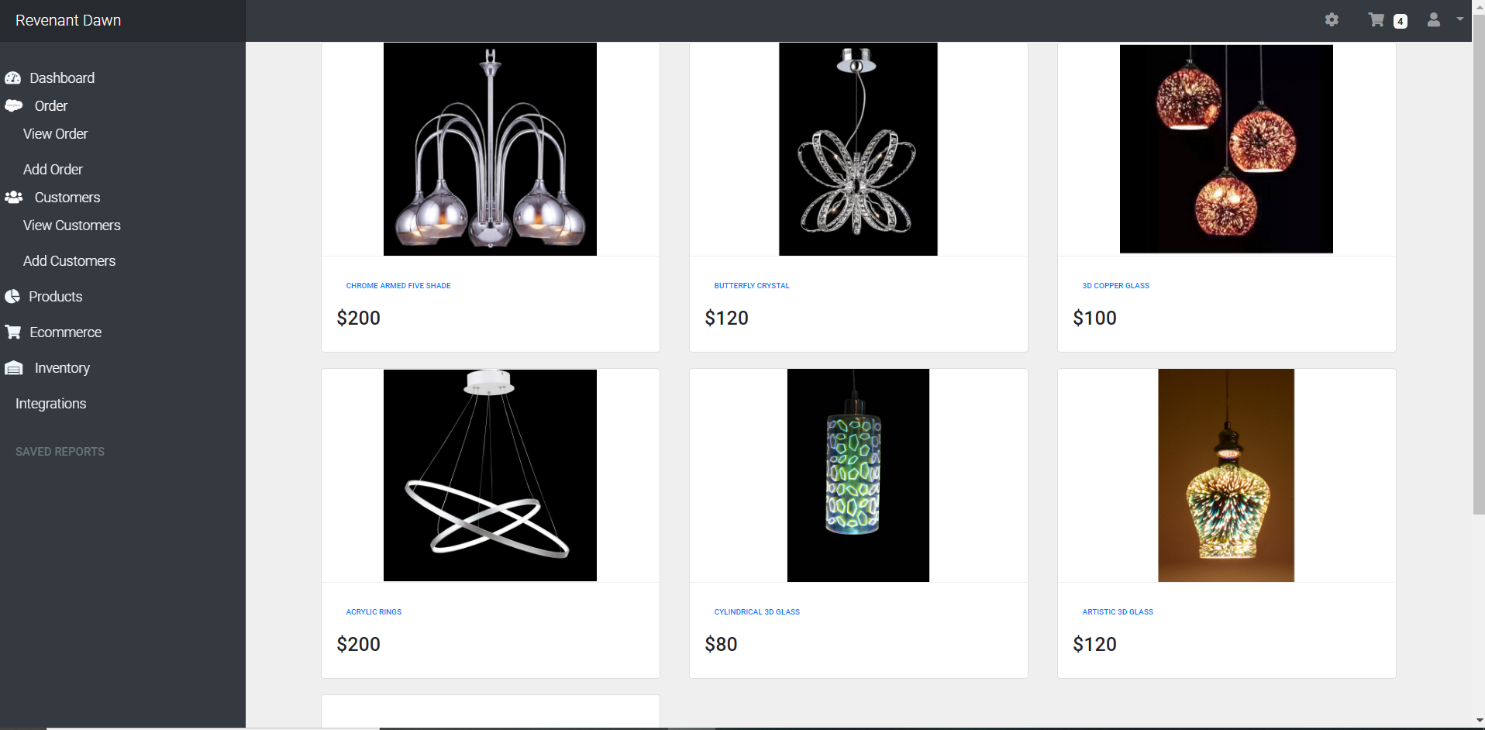

## 6.11 Product detail

User can view information and add to cart section after choosing the specific product.

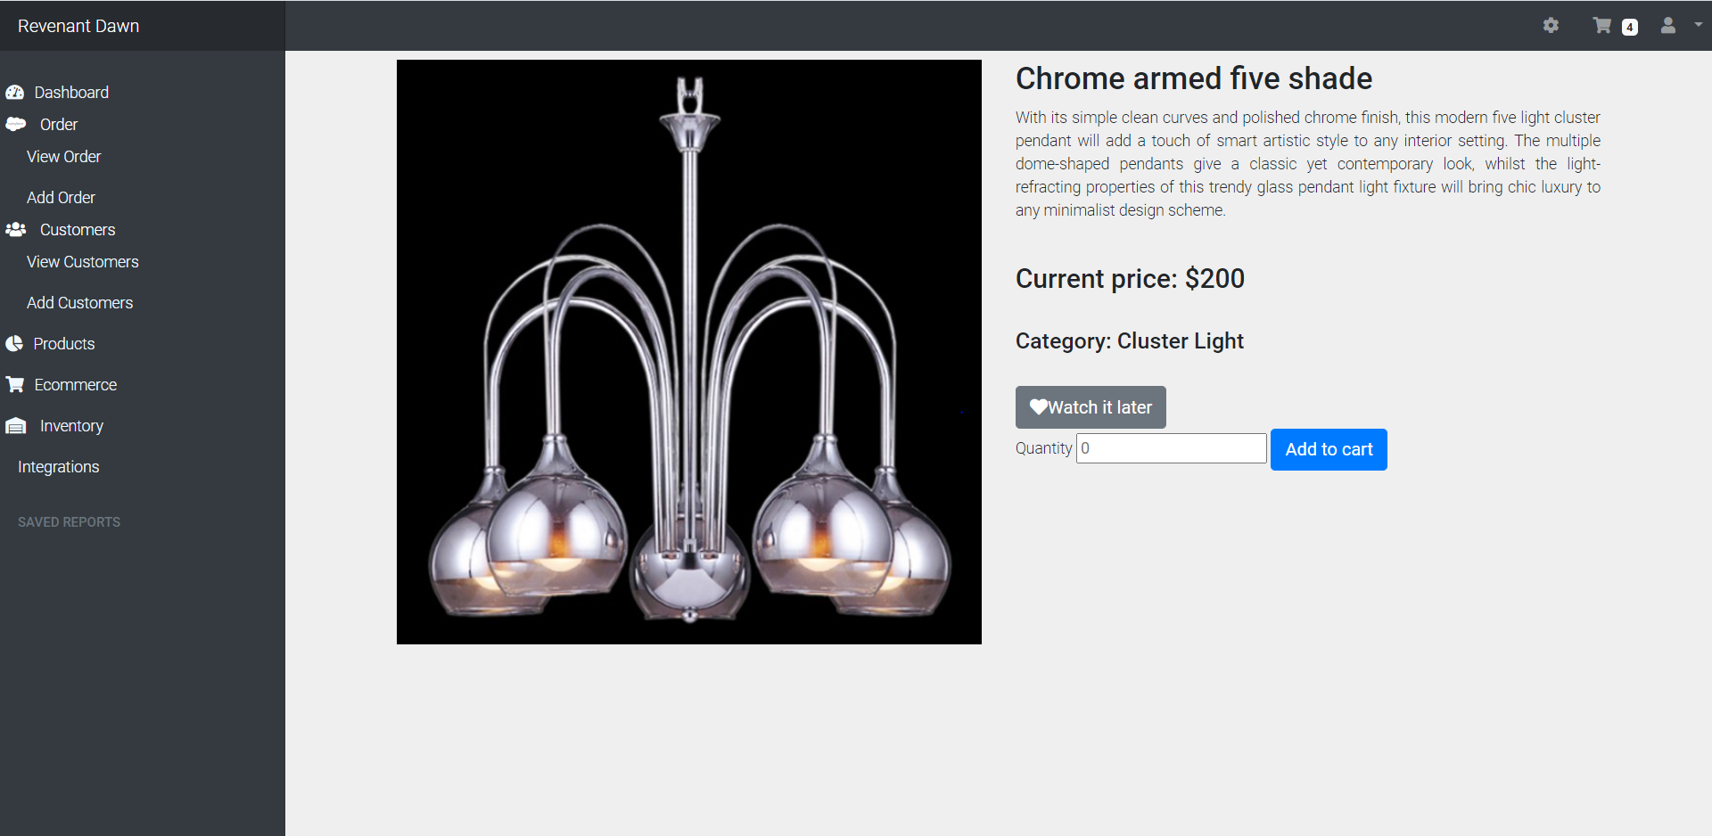

## 6.12 Watch it later Section

Product can be enlisted by the user to watch it later when they want. It is located at the top right corner of the website.

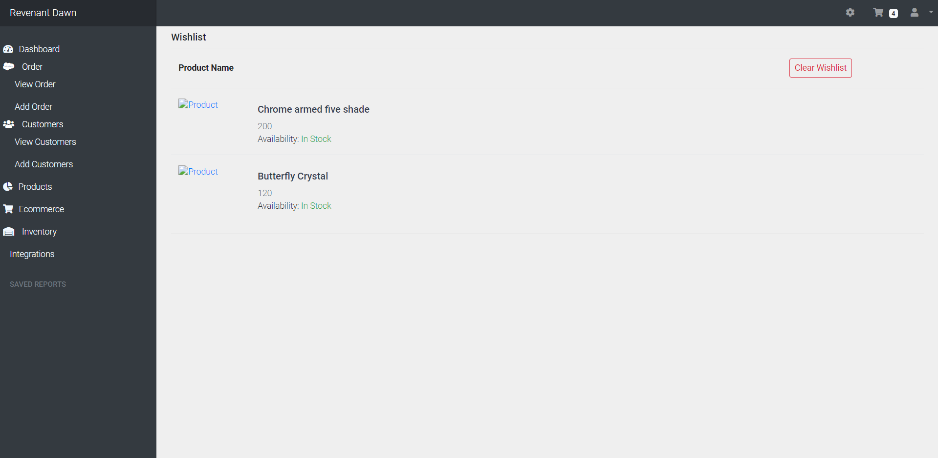

## 6.13 Checkout

User can check out the item with their Billing information’s like Name, Email and address and it is available when the user clicks on cart panel. User can check out with the help of credit card as well as PayPal for easy payment.

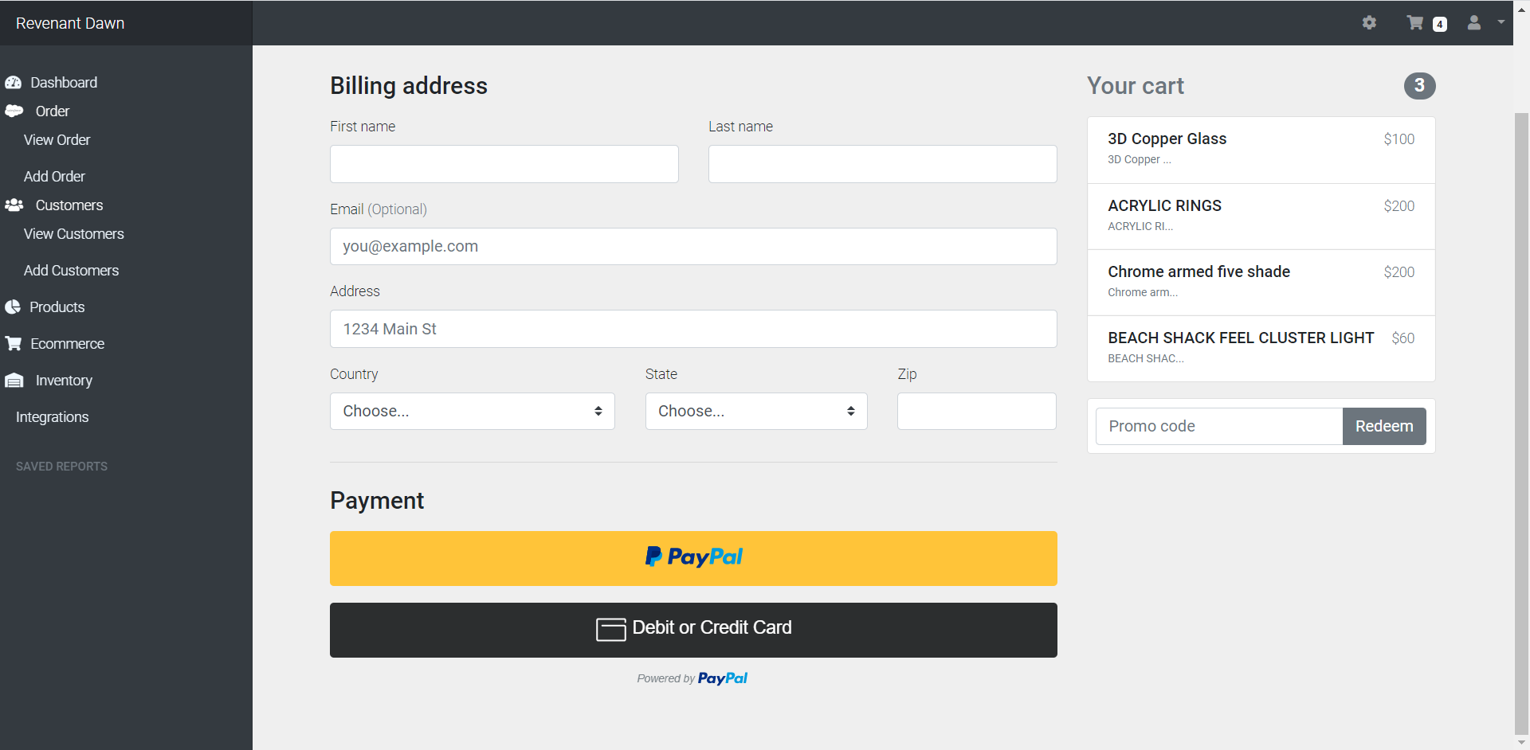

## 6.14 Add stock to inventory

With the help of form, user can easily add any product to inventory for tracking or inventory management by clicking on add.

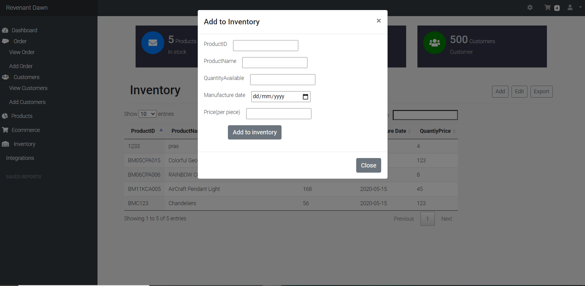

# **Conclusion**

This manual serves as an overview on how our website cloud application works. These are the set of the instruction needed to fully understand the functionality of the website. Further information will be added as per necessary under supervision.

# **Appendix**

## 7.1 Site Map

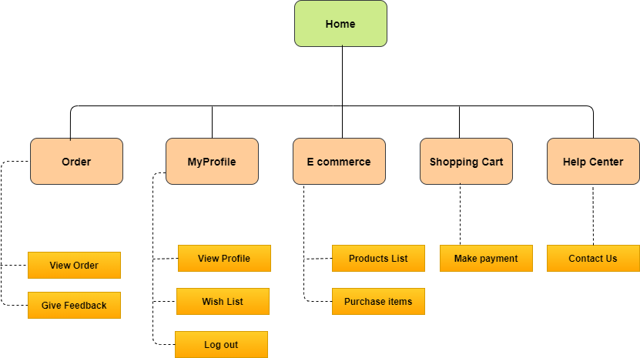

## 7.2 Publishing the Document

Website link: <https://ordermanagementsystemv1.herokuapp.com/>

Alternatively, user can scan QR Code given below to gain access to website as well.

Developed by: Pranish, Madan, Nabin, Paras, Kanchan.

Copyright © 2020. All Rights Reserved

End of the document